**PYTHON NANG CAO LAB_6**

**Tên: PHIMMACHAK Lattakone**

**MSSV:227480201is001**

**CÂU1**.:

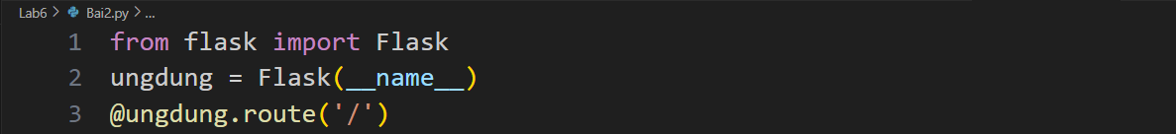

**CÂU2:** Xây dựng trang web “Xin chao!”

Kết quả 2:

**CÂU4:** Điều chỉnh chữ ‘Xin chao!’ và điều chuyển về trang Đại học Văn Lang

**Kết quả 4:**

**Câu5:** Thay đổi cổng web và thêm định tuyến trang con

**Kết quả 5:**

**CÂU6:** Định tuyến đến một môn học

**

**

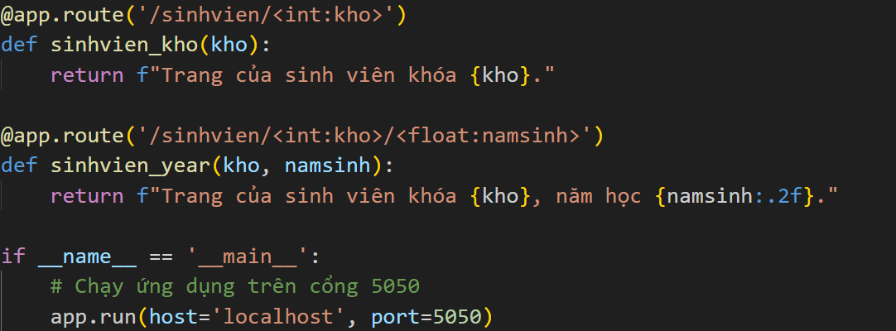

Kết quả 6.2:

**Câu7: Web templating: truyền biến đơn**

**App.py**

**Templates**

**Hello.html**

**Kết quả7:**

**Câu 8:**

**Kết quả 8:**

**Câu9: Web templating: Truyền biến kiểu danh sách**

**App.py**

**Abc.html**

**Kết quả9:**

**CÂU10:**

**App.py**

**Index.html**

**Img- icon**

**Kết quả10:**

**Câu11:**

**Kết quả11:**

**Câu12:**

**App.py**

**config.py**

**database.py**

**models.py**

**services.py**

**Layout.html**

**Index.html**

**create_user.html**

**Kết quả12:**

**Câu13:**

**App.py**

**Index.html**

**Search.html**

**upload.html**

**Kết quả13:**

1. **Tải lên tập tin**

1. **Tìm kiếm**

**Câu14:**

**App.py**

**Templates**

**Index.html**

**Kết quả14:**

**Câu15:**

**User.html**

**Kết quả15:**

**Câu16:**

**404.html**

**500.html**

**Kết quả16:**

**Câu17:**

**Kết quả17:  
**

**Câu18:**

**Kết quả 18:**

**Câu19:**

**Kết quả 19:**

**Câu20:**

**Kết quả20:**

